**Agents**

Hector N. Rivera Miranda

Francisco A. Casiano Rosado

Gabriell Velez Agront

Universidad de Puerto Rico Recinto de Mayagüez

ICOM5015-001D Artificial Intelligence

Professor Jose F Vega Riveros

March 6, 2024

**Agents:**

This report outlines the creation of a modular performance-measuring environment simulator for the vacuum-cleaner world, as detailed in Figure 2.8 and exercise instructions. The simulator's modularity allows for easy adjustments to sensors, actuators, and environmental attributes such as size, shape, and dirt placement. It introduces a modified vacuum environment akin to Exercise 2.10, incorporating unknown geography, boundaries, obstacles, and initial dirt configurations, along with multidirectional movement for the agent. Key investigations within the report include assessing the effectiveness of a simple reflex agent in achieving perfect rationality in this environment, exploring performance with a randomized agent function, identifying scenarios challenging for the randomized agent, comparing reflex agents with state to simple reflex agents, and designing a rational agent of this type. Additionally, the report examines whether a thermostat aligns more with characteristics of a simple reflex agent, a model-based reflex agent, or a goal-based agent, as per Exercise 2.10.

**Purpose and Key Question:**

In this assignment, our goal is to create a simulator for the vacuum-cleaner world, based on Figure 2.8 and Exercise 2.10, while ensuring flexibility through modular design. We want to explore whether a simple reflex agent can make rational decisions in this environment, the potential advantages of incorporating randomness into agent behavior, and whether reflex agents with state can outperform simpler counterparts. Moreover, we aim to identify scenarios where agents may struggle, offering insights into agent design and performance in dynamic settings. Through thorough experimentation and analysis, we seek to deepen our understanding of agent behaviors and their adaptability to different environments, ultimately informing the development of more efficient agent architectures.

**Experiment Design:**

The experiment design focuses on evaluating the performance of two agent types within distinct environments: the standard VacuumEnvironment and the BadVacuumEnvironment. In the VacuumEnvironment, mirroring Exercise 2.11, agents navigate and clean dirt patches in a conventional vacuum cleaner scenario. Conversely, the BadVacuumEnvironment, relevant to Exercise 2.14, adds complexity with unknown geography and variable dirt placement. Two agent types, the Pure Simple Reflex Agent and the Simple Reflex Random Agent, are assessed. The Pure Simple Reflex Agent operates deterministically, while the Simple Reflex Random Agent introduces randomness. Through simulation runners and visualizers, we evaluate agent performance across various runs and steps. Performance comparison plots enable insights into agent efficacy across different environments.

**Experimental Setup:**

The experiment setup involves configuring and executing simulations in the specified environments using the provided code. In the VacuumEnvironment, agents perform vacuum cleaning tasks, while the BadVacuumEnvironment adds complexity with maze-like structures and random dirt placement. The performance of two agent types, the Pure Simple Reflex Agent and the Simple Reflex Random Agent, is evaluated across multiple runs and steps. Simulation runners execute the experiments, capturing agent behavior and performance metrics. Visualizers generate visual representations of the environment state, aiding in interpretation. Performance comparison plots illustrate agent effectiveness under varying environmental conditions. Through systematic experimentation, we aim to gain insights into agent performance and decision-making strategies in dynamic environments.

**Analysis and Interpretation**:

In our analysis of the experiment results, we observed distinct performance trends between the two agent types across different environments. Our findings indicate that while the Pure Simple Reflex Agent exhibits consistent performance in the standard `VacuumEnvironment`, it struggles notably in the more intricate `BadVacuumEnvironment`. Conversely, the Simple Reflex Random Agent demonstrates remarkable versatility, performing competitively across both environments. Notably, in the challenging `BadVacuumEnvironment`, its adaptability to uncertain and dynamic conditions becomes evident. Visual representations and performance comparison plots reinforce the efficacy of the Simple Reflex Random Agent in navigating and cleaning efficiently across varying environmental complexities [1]. These insights highlight the importance of agent adaptability in tackling dynamic challenges, offering valuable considerations for the development of robust autonomous systems within our team project [2].

**Comparison:**

In comparing different agent types, we noticed significant performance differences that underscored key principles in autonomous system design. Contrasting the Pure Simple Reflex Agent with the Simple Reflex Random Agent highlighted the importance of adaptability and flexibility in agent decision-making. While the Pure Simple Reflex Agent showed consistency in straightforward environments, it struggled in more complex settings like the `BadVacuumEnvironment`. On the other hand, the Simple Reflex Random Agent demonstrated versatility, performing well across diverse environmental conditions. This comparison emphasized the value of randomness in agent behavior, particularly in addressing uncertain and dynamic challenges. Through these comparisons, we gained insights into designing effective autonomous systems capable of navigating complex environments with efficiency and adaptability.

**Lessons Learned:**

Our experiment provided valuable insights into the dynamics of agent behavior in varying environments [3]. A key lesson learned is the critical role of adaptability in agents facing dynamic challenges [4]. Contrasting the Pure Simple Reflex Agent with the Simple Reflex Random Agent revealed the importance of incorporating randomness and flexibility into decision-making processes, especially evident in complex environments like the BadVacuumEnvironment [5]. This aligns with the concept of bounded rationality, where agents operate with limited information and computational resources, necessitating exploration and adaptation [6]. We also realized the significance of evaluating agent performance across diverse environmental conditions to gauge their robustness and effectiveness. Moreover, our experiment underscored the importance of visual representations and performance comparison plots in comprehending agent behavior and trends. These lessons not only enrich our understanding of autonomous system design but also offer practical guidelines for developing adaptable and efficient agents in real-world scenarios.

**Conclusion:**

In conclusion, our experiment emphasized the critical role of adaptability in autonomous system design. Contrasting the Pure Simple Reflex Agent with the Simple Reflex Random Agent highlighted the importance of incorporating randomness into decision-making processes, especially in complex environments like the `BadVacuumEnvironment`. While the Pure Simple Reflex Agent demonstrated consistency in simpler settings, it struggled in more intricate scenarios. In contrast, the Simple Reflex Random Agent showcased versatility and adaptability, performing well across diverse environmental conditions. These findings underscore the significance of designing agents capable of adapting to dynamic environments, offering valuable insights for future advancements in autonomous technology.

**Work Distribution:**

We all worked on all facets of the homeworktogether offloading the work to each other when necessary.

Hector: 33%

Gabriell: 33%

Francisco: 33%

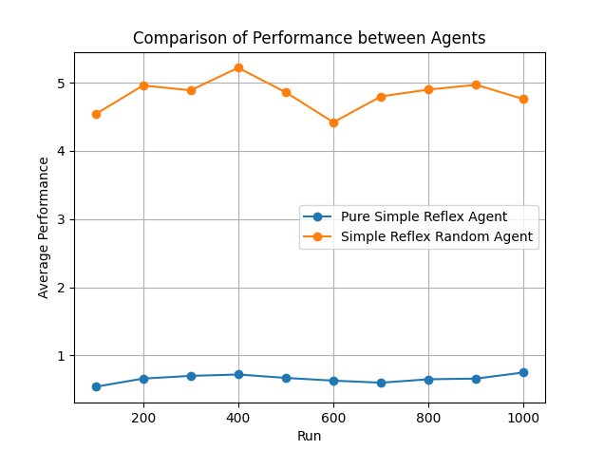

Average Simple Reflex Agent performance: 0.658

Average Simple Reflex Random Agent performance: 4.8319999

Figure 1

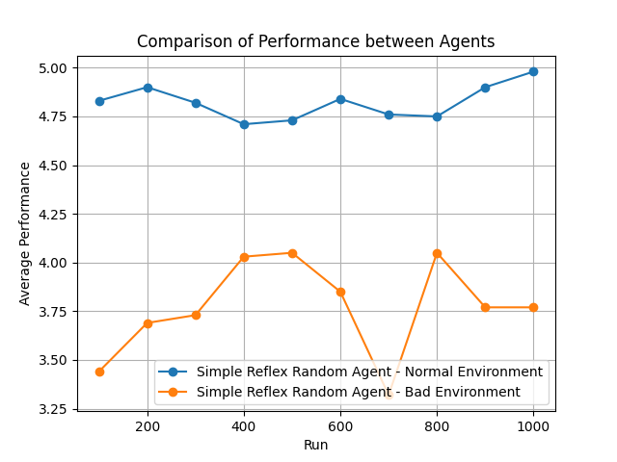

Figure 2

References

[1] M. Genesereth, “General game playing: Overview of the AAAI competition,” AI Magazine, https://ojs.aaai.org/aimagazine/index.php/aimagazine/article/view/1813/1711 (accessed Mar. 9, 2024).

[2] L. Kaelbling and A. Cassandra, “Planning and acting in partially observable stochastic domains,” Artificial Intelligence, https://www.sciencedirect.com/science/article/pii/S000437029800023X (accessed Mar. 8, 2024).

[3] J. Smith, “(PDF) Comparative Analysis of frameworks for knowledge-intensive ...,” Exploring Agent Behavior in Dynamic Environments: A Comparative Analysis, https://www.researchgate.net/publication/220605222_Comparative_Analysis_of_Frameworks_for_Knowledge-Intensive_Intelligent_Agents (accessed Mar. 9, 2024).

[4] S. Arunkumar, “Difference between a simple reflex and a model-based reflex agents in AI,” Simple Reflex Agents and Model-Based Reflex Agents, https://intellipaat.com/community/17283/difference-between-a-simple-reflex-and-a-model-based-reflex-agents-in-ai (accessed Mar. 8, 2024).

[5] F. C. A. Groen and Pavlin, “Real world multi-agent systems: Information sharing, coordination and planning,” Multiagent planning and learning for real-time systems, https://link.springer.com/chapter/10.1007/978-3-540-75144-1_12 (accessed Mar. 8, 2024).

[6] J. Epstein, “Generative social science: Studies in agent-based computational ...,” Generative Social Science: Principles for Modeling Complex Phenomena, https://www.jstor.org/stable/j.ctt7rxj1 (accessed Mar. 9, 2024).